LECTURE 6
The curve of the second order

Circle
Circle is called a locus of points equidistant from the same point.
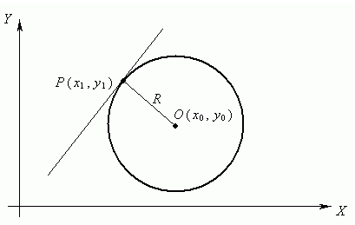

Equation of a circle is given by

(x - x₀)² + (y - y₀)² = R²,

where x₀ and y₀ - the coordinates of the center of the circle, and R - the radius of the circle. If the center of the circle is at the origin, then the equation of the form

x² + y² = R².

Ellipse

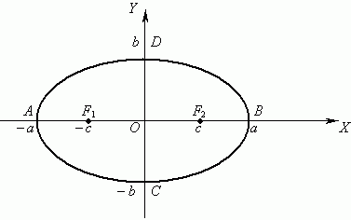
Ellipse is the locus of points for which the sum of the distances to two fixed points (foci) is, for all points of the ellipse is the same constant (this constant value must be greater than the distance between the foci).
The simplest equation of the ellipse
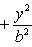
If a> b foci of the ellipse lie on the X-axis (Fig. 1), with a <b foci of the ellipse lie on the Y-axis.
Segment , where 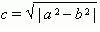is called the focal length. Segment AB=2a is called the major axis of the ellipse, and the segment CD = 2b - minor axis of the ellipse. The number of e = c / a, e <1 is called the eccentricity of the ellipse.

Hyperbola

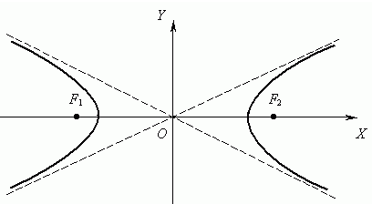

Hyperbola is the locus of points, modulus of the difference of the distances from which to the two given points F1 and F2, is a constant.
The simplest equation of the hyperbola

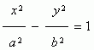
Segment , where is called the focal length. Segment AB=2a is called the real axis of the hyperbola, and the segment CD = 2b - imaginary axis of the hyperbola. The number of e = c / a, e >1 is called the eccentricity of the hyperbola.
Lines y = ± (b / a) x are called the asymptotes of the hyperbola.

Parabola
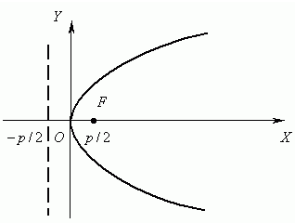

A parabola is the locus of points equidistant from a given point F, called the focal point of the parabola, and this line does not pass through this point and called the directrix of the parabola.

The simplest equation of the parabola

Here the X-axis is the axis of symmetry of the parabola.

